RAFFLE PRIZES
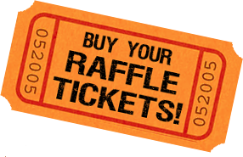

$5 each
3 for $10, 5 for $20, or 10 for $40

Tickets will be sold at the studio, and through both shows. Winners will be picked during a LIVE Facebook video after the conclusion of our 7pm show!

Tickets are available to all dancers, families and friends! Buy your tickets, and pick which prize YOU want to WIN!!

THANK YOU to the Borr, Loscerbo, Sprowl, & Tajiani families
for your donations!!

FREE TUITION 2017/2018 SEASON $100 Dance/MDCwear for 2017/2018 season
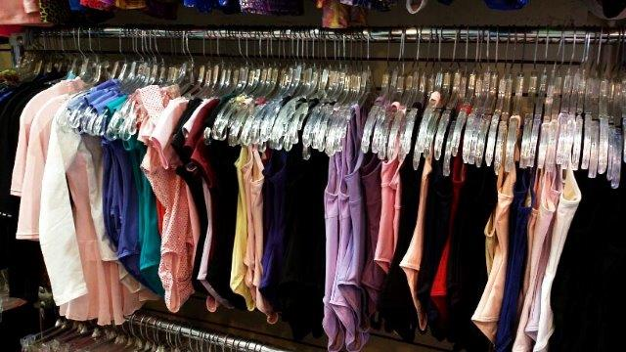
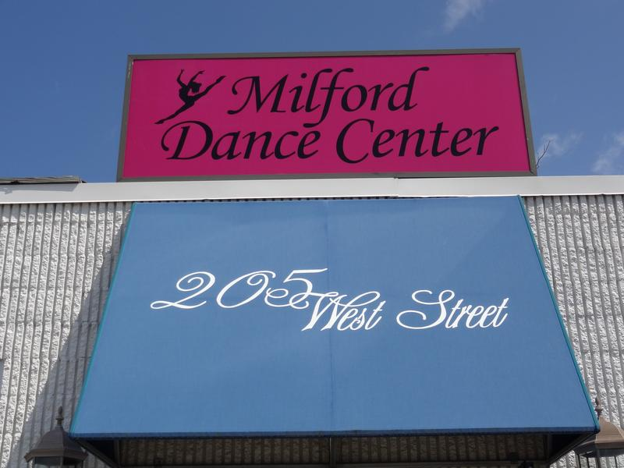

$50 Regal Cinema Gift Card/Candy basket $100 worth of Lularoe Leggings

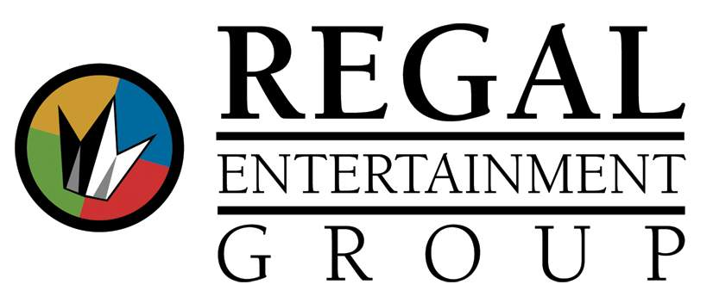

Pure Haven Essentials Basket Thirty One Bags
Basket includes shampoo, conditioner, Soft Utility Tote & New Day Tote
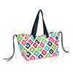
moisturizer, soap, and SO much more!! Valued at $116!
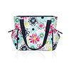
12 items total! Valued at over $190!!!

Wachusett Brewing Co. Basket Tuscan Kitchen Basket
TWO PRIZES!! Includes wine, salami, olive oil, balsamic,
Each basket includes growler & beer! dried pasta, and crackers!
Valued at over $50 each! Valued at over $100!
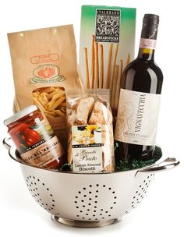
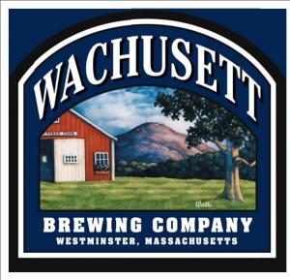

$50 worth of lottery tickets Bubble Music Man Party
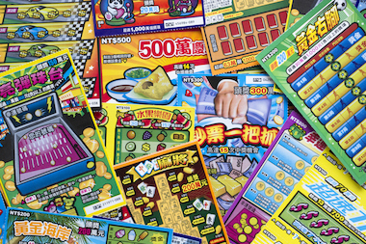
Winner will receive 1 free weekday Bubble Party. The party will feature 1 hour of kid friendly music, interaction and hundreds of bubbles!! Valued at $200!

$50 Pepperoncini’s Gift Card
